2a) The transport protocol that is used is TCP

2b) TCP allows a successful connection with the computer and server and HTTP sends data from server to client allowing the website to be viewed.

2c)

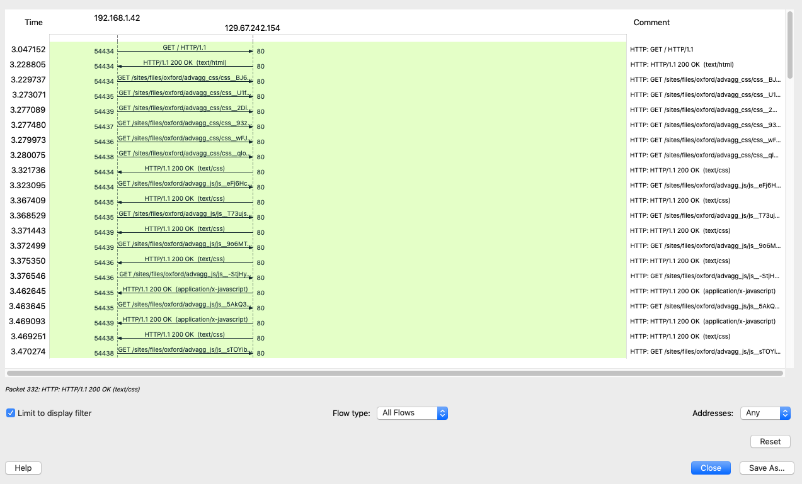

3a)

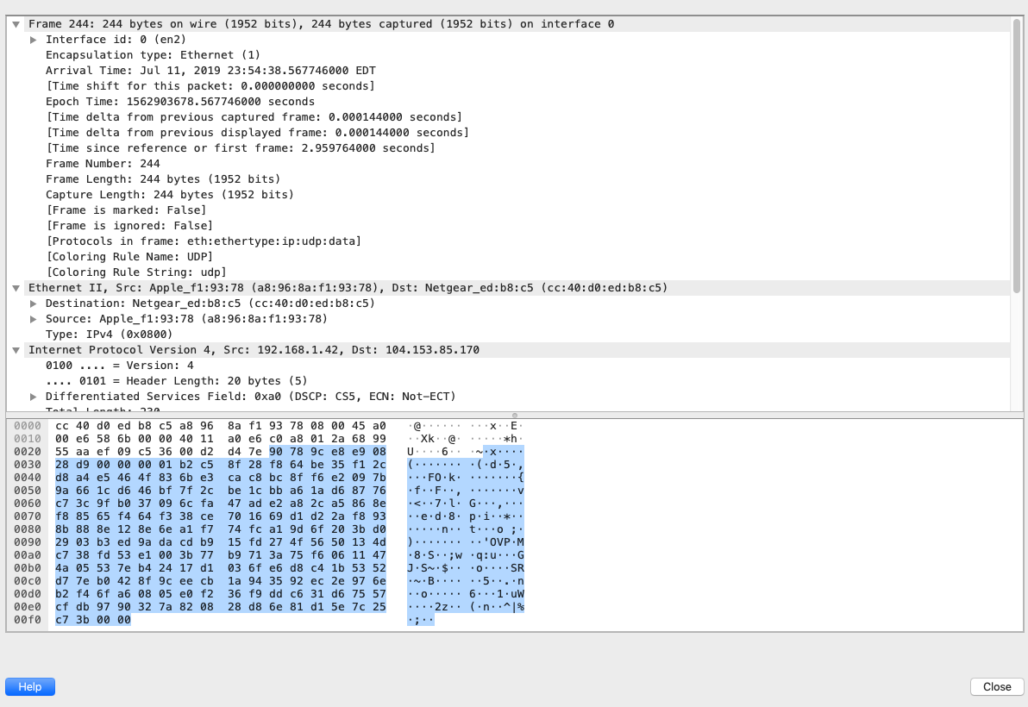

3b)

|  |  |
| --- | --- |
| Layer | Protocol |
| IP | Network |
| TCP | Transport |
| HTTP | Session |

4a)

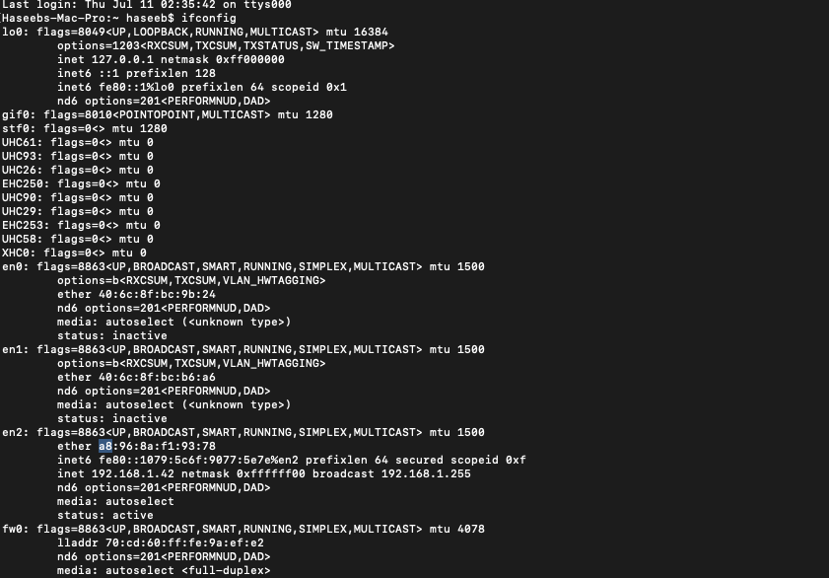

4b)

4c)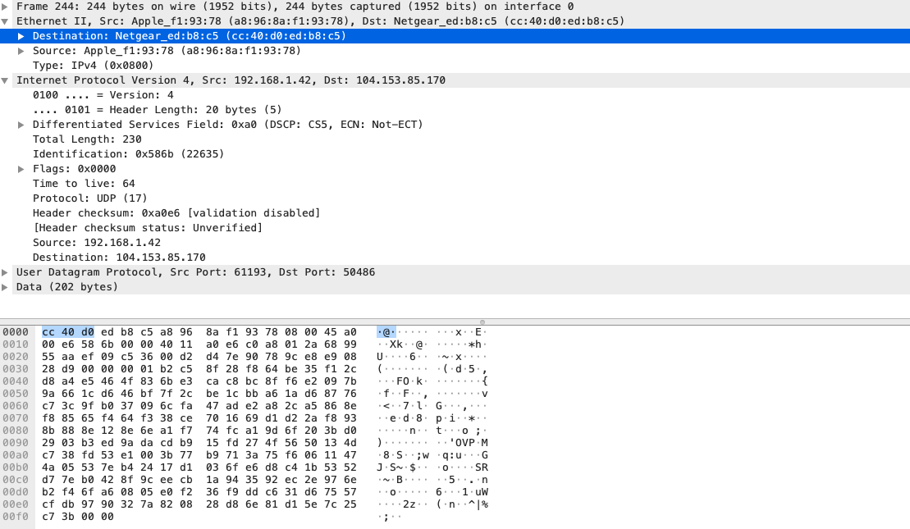

The address is of my netgear router not the ethernet address of [www.ox.ac.uk](http://www.ox.ac.uk)

5a)

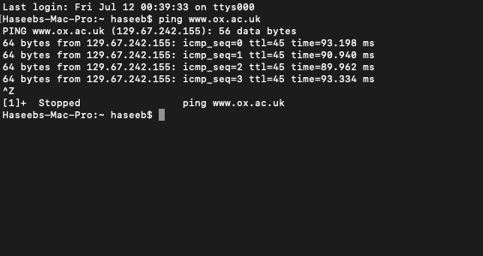

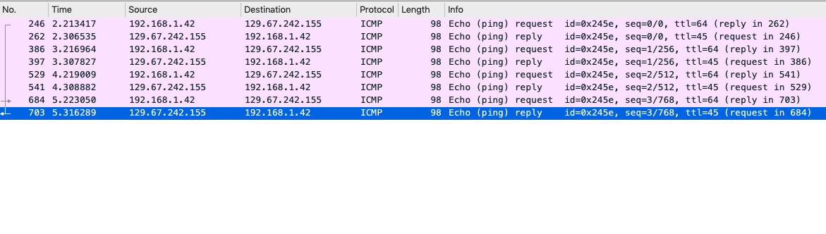

5b)

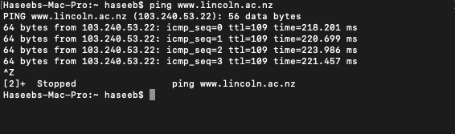

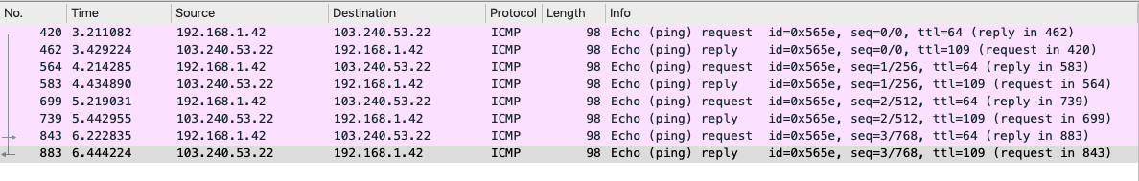

The time can be seen greater in the website as it does have a .nz domain meaning it is from new zeland which is a greater distance than than the website prior, so it can be seen that the packets are travelling a greater distance from my machine to the server.